
FT/PHQP/1223/A 17-JUN-2023
FIRST TERM EXAMINATION (2023-24)
Subject: PHYSICS  Grade: XII |  |  |  | Max. Marks:70  Time: 3 Hrs
Name: |  |  | Section: |  |  | Roll No:
General Instructions:
- All questions are compulsory. There are 35 questions in all.
- This question paper has four sections: section A, Section B, Section C and Section D.
- Section A contains eighteen questions, fifteen MCQ and three Assertion Reasoning based of 1 mark each, Section B contains seven questions of two marks each, Section C contains five questions of three marks each, Section D each contains two case study-based questions of four marks each and
Section E contains three long answer questions of five marks.
- There is no overall choice. However, an internal choice has been provided in section B, C, D and E. You have to attempt only one of the choices in such questions
- You may use the following physical constants wherever necessary:
µ_{o = 4π x 10}⁻⁷H/m c= 3 x 10⁸m/s Mass of electron m_{e} = 9.1x10⁻³¹ kg e= 1.6 x 10⁻¹⁹C
- = 9x 10⁹Nm²/C² = 8.85 x 10 ⁻¹² C²/Nm² Avogadro’s number = 6.023 X 10²³ per gram mol
SECTION A
This section consists of 18 multiple choice questions
 | A line charged rod is placed between two insulated conducting spheres as shown. The spheres have no net charge. Region, I has the same polarity as Region  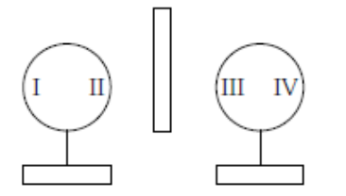 |  |  |  |  |  |  | 1
 | a. | III only |  |  | b. |  | IV only
 | c. | II & III only |  |  | d. |  | II & IV only
 | Concentric equipotential surfaces due to a charged body placed at the center are shown. Identify the polarity of the of the charge |  |  |  | 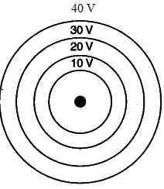 |  |  | 1
 | a. | Positive point charge |  |  | b. |  | Negative point charge
 | c. | Point dipole |  |  | d. |  | Two equal and like charges
 | The resistivity of a conductor in which a current density of 2.5 Am^{–2} is found to exist, when an electric field of 15 Vm^{–1} is applied on it |  |  |  |  |  |  | 1
 | a. | 2 Ωm |  |  | b. |  | 6 Ωm
 | c. | 4 Ωm |  |  | d. |  | 8 Ωm
- 3 | An electron beam, projected along + X-axis, experiences a force due to a magnetic field along the + Y-axis. What is the direction of the magnetic field? |  |  |  |  |  |  | 1
 | a. | +Z |  |  | b. |  | -Z
 | c. | -X |  |  | d. |  | -Y
 | Fig shows the field lines of a negative point charge. Give the sign of the work done by the external agency in moving a small negative charge from B to A. |  |  |  | 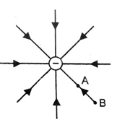 |  |  | 1
 | a. | Positive |  |  | b. |  | Negative
 | c. | No work done |  |  | d. |  | Not sufficient information
 | If the electric flux entering and leaving an enclosed cubical surface respectively is ɸ₁ and ɸ₂ , the electric charge inside the surface will be |  |  |  |  |  |  | 1
 | a. | (ɸ₂ ₋ ɸ₁)Ɛ₀ |  |  | b. |  | (ɸ₁ ₋ ɸ₂)Ɛ₀
 | c. | (ɸ₂ ₋ ɸ₁)/Ɛ₀ |  |  | d. |  | (ɸ₁ ₋ ɸ₂) /Ɛ₀
 | The electric potential V as a function of distance X is shown in the figure. The graph of the magnitude of electric field intensity E as a function of X is |  |  |  | 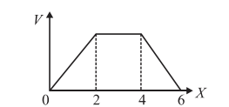 |  |  | 1
 | a. | 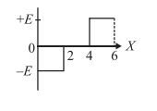 |  |  | b. |  | 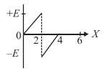
 | c. | 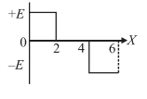 |  |  | d. |  | 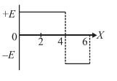
 | The resistivity of following material or materials increases with the increasing of temperature. |  |  |  |  |  |  | 1
 | a. | Copper |  |  | b. |  | Diode
 | c. | Carbon |  |  | d. |  | All of them
 | In a region, steady and uniform electric and magnetic fields are present. These two fields are parallel to each other. A charged particle is released from rest in this region. State the path of the particle followed in the region. |  |  |  |  |  |  | 1
 | a. | Circular |  |  | b. |  | Parabola
 | c. | Straight |  |  | d. |  | Elliptical
 | The magnetic moment of a current (l) carrying circular coil of radius (r) and number of turns (N) varies as |  |  |  |  |  |  | 1
 | a. | NI r |  |  | b. |  | NIA
 | c. | πNIr² |  |  | d. |  | NI/πr²
 | An uncharged sphere of metal is placed in between two charged plates as shown. The lines of force look like |  |  |  |  |  |  | 1
 | a. | 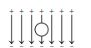 |  |  | b. |  | 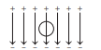
 | c. | 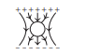 |  |  | d. |  | 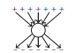
 | A dipole is placed parallel to the electric field. If W is the work done in rotating the dipole from 0° to 60°, then calculate work done in rotating it from 0° to 180°. |  |  |  |  |  |  | 1
 | a. | 2W |  |  | b. |  | 3W
 | c. | 4W |  |  | d. |  | W/2
 | If the galvanometer and cell are interchanged at the balance point of the wheat stone bridge? Then galvanometer current would be |  |  |  |  |  |  | 1
 | a. | More |  |  | b. |  | Less
 | c. | Zero |  |  | d. |  | Insufficient information
 | A charged particle of mass m and charge q travels on a circular path of radius r that is perpendicular to the magnetic field B. The time-taken by the particle to complete one revolution is |  |  |  |  |  |  | 1
 | a. | 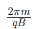 |  |  | b. |  | 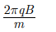
 | c. | 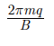 |  |  | d. |  | 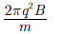
 | Which of the following statements is correct? |  |  |  |  |  |  | 1
 | a. | Kirchhoff’s law states that the current traveling towards a junction equals the voltage drop |  |  | b. |  | The current flowing towards a junction is equal to the resistance across the junction, according to Kirchhoff’s law.
 | c. | The current flowing into a junction is equal to the current exiting the junction, according to Kirchhoff’s law. |  |  | d. |  | Kirchhoff’s law states that the current traveling towards a junction is equal to the sum of all currents in the circuit.
Assertion reason
16. | Two statements are given-one labelled Assertion (A) and the other labelled Reason (R). Select the correct answer to these questions from the codes (a), (b), (c) and (d) as given below. a) Both A and R are true and R is the correct explanation of A  b) Both A and R are true and R is NOT the correct explanation of A 1  c) A is true but R is false  d) A is false and R is also false  Assertion: Ohm’s law is universally applicable for all conducting elements.  Reason: all the conducting material are ohmic conductors. |  |  |  |  |  |  | 1
 | A | (a) |  |  | B |  | (b)
 | C | (c) |  |  | D |  | (d)
17. | Two statements are given-one labelled Assertion (A) and the other labelled Reason (R). Select the correct answer to these questions from the codes (a), (b), (c) and (d) as given below. a) Both A and R are true and R is the correct explanation of A  b) Both A and R are true and R is NOT the correct explanation of A 1  c) A is true but R is false  d) A is false and R is also false  Assertion: A proton and an alpha particle having the same kinetic energy are moving in circular paths in a uniform magnetic field. The radii of their circular paths will be equal.  Reason: Any two charged particles having equal kinetic energies and entering a region of uniform magnetic field B in a direction perpendicular to B, will describe circular trajectories of equal radii. |  |  |  |  |  |  | 1
 | A | (a) |  |  | B |  | (b)
 | C | (c) |  |  | D |  | (d)
18. | Two statements are given-one labelled Assertion (A) and the other labelled Reason (R). Select the correct answer to these questions from the codes (a), (b), (c) and (d) as given below. a) Both A and R are true and R is the correct explanation of A  b) Both A and R are true and R is NOT the correct explanation of A 1  c) A is true but R is false  d) A is false and R is also false  Assertion: Electric field inside a conductor is zero.  Reason: The potential at all the points inside a conductor is same. |  |  |  |  |  |  | 1
 | A | (a) |  |  | B |  | (b)
 | C | ( c) |  |  | D |  | (d)
 | SECTION B
19. | A horizontal overhead power line carries a current of 90 A in east to west direction. What is the magnitude and direction of the magnetic field due to the current 1.5 m below the line?  OR  A straight horizontal conducting rod of length 0.45 m and mass 60 g is suspended by two vertical wires at its ends. A current of 5.0 A is set up in the rod through the wires. What magnetic field should be set up normal to the conductor in order that the tension in the wires is zero? |  |  |  |  |  |  | 2
20. | Prove that Electric field at the surface of a charged conductor is  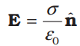 |  |  |  |  |  |  | 2
21. | Consider three charges q₁, q₂, q₃ each equal to q at the vertices of an equilateral triangle of side l. What is the force on a charge Q (with the same sign as q) placed at the centroid of the triangle, as shown in fig? |  |  |  |  | 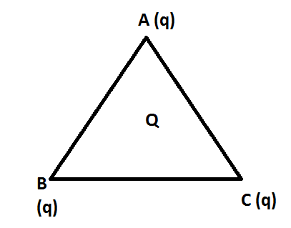 |  | 2
22 | - The electron drift speed is estimated to be only a few mm s^{–1} for currents in the range of a few amperes? How then is current established almost the instant a circuit is closed?  - Are the paths of electrons straight lines between successive collisions (with the positive ions of the metal) in the (i) absence of electric field, (ii) presence of electric field? |  |  |  |  |  |  | 2
23 | Use Kirchhoff ’s rules to determine the potential difference between the points A and D when no current flows in the arm BE of the electric network shown in the figure. |  |  |  |  | 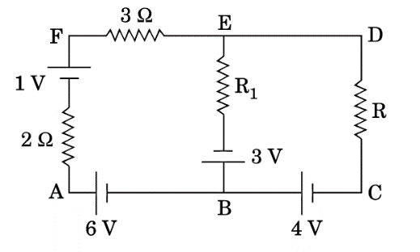 |  | 2
24 | Consider two hollow concentric spheres, S₁ and S₂, enclosing charges 2Q and 4Q respectively as shown in the figure. Find out the ratio of the electric flux through them. |  |  |  |  | 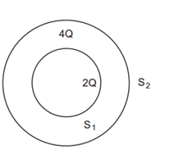 |  | 2
25. | (a) Why alloys like constantan or manganin are used for making standard resistors?  (b) Explain with the help of graph the variation of conductivity with temperature for a metallic conductor |  |  |  |  |  |  | 2
 | SECTION C
26. | A dipole of dipole moment p​ is placed in a uniform electric field E. Derive the expression for net force F on the dipole and the torque is τ with the help of suitable diagram.  OR |  |  |  |  |  |  | 3
 | The electric field in the given figure is directed along +X direction and given by Ex​=5Ax​+2B, where E is in NC⁻¹ and x is in meter, A and B are constants with dimensions. Taking A=10 NC⁻¹m⁻¹ and B=5 NC⁻¹, calculate the electric flux through the cube. |  |  |  |  | 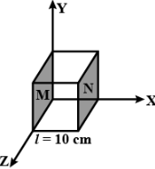 |  | 3
27. | A capacitor of capacitance C is charged fully by connecting it to a battery of emf E. It is then disconnected from the battery. If the separation between the plates of the capacitor is now doubled, how will the following change?  Charge stored by the capacitor.  Field strength between the plate  Energy density between the plates |  |  |  |  |  |  | 3
28. | - Find the equivalent capacitance between A and B in the combination given below. Each capacitor is 2µF capacitance.  - If a dc source of 5 V is connected across AB, how much charge is drawn from the source and what is the energy stored in the network? |  |  |  | 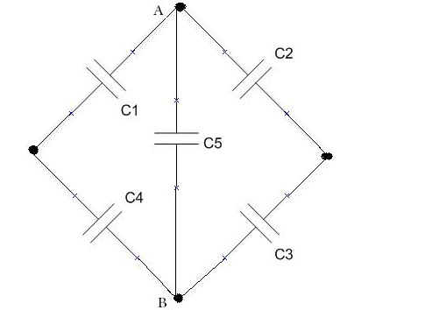 |  |  | 3
29. | Three infinitely long parallel straight current carrying wires A, B and C are kept at equal distance from each other as shown in the figure. The wire C experiences net force F. Evaluate the net force on wire C, when the current in wire A is reversed. |  |  |  | 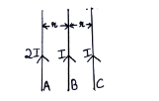 |  |  | 3
30 | Two cells of emfs ε1, ε2 and internal resistance r1 and r2 respectively are connected in parallel as shown in the figure. Deduce the expressions for  (i) the equivalent e.m.f. of the combination,  (ii) the equivalent resistance of the combination, and  (iii) the potential difference between points A and B |  |  |  | 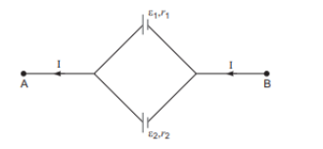 |  |  | 3
 | SECTION D
31. | - Derive an expression for the capacitance of a parallel plate capacitor when a dielectric slab of dielectric constant K and thickness t but of same area as that of the plates is inserted between the capacitor plates. (d= separation between the plates).  - Calculate the amount of work done to dissociate a system of three charge 1 μC, 1 μC and - 4 μC placed on the vertices of an equilateral triangle of side 10 cm.  OR  - Draw the equipotential surfaces due to an electric dipole. Locate the points where the potential due to the dipole is zero. “For any charge configuration, equipotential surface through a point is normal to the electric field.” Justify.  - Three concentric metallic shells A, B and C of radii a, b and c (a < b < c) have surface charge densities +σ, - σ and + σ respectively as shown in the figure.  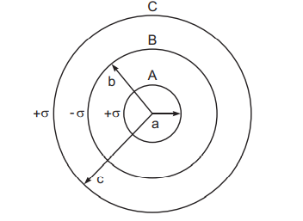  If shells A and C are at the same potential, then obtain the relation between the radii a, b and c |  |  |  |  |  |  | 5
32. | - Apply Gauss law to obtain the expression for the electric field intensity at a point due to an infinitely long, thin, uniformly charged straight wire.  - Obtain an expression for the magnitude of the net electric field at the origin due to all three charges shown in the above figure and state its direction.  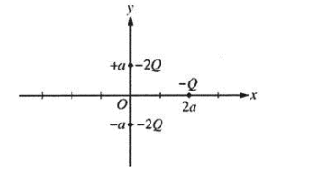  OR  - Derive an expression for the magnitude of electric field intensity at any point along the equatorial line of a short electric dipole. Give the direction of electric field intensity at that point.  - If three infinite chrged sheets of uniform surface charge densities +σ , +2σ, and -4σ are placed as shwon in figure, then find out electric field intensities at points A and C  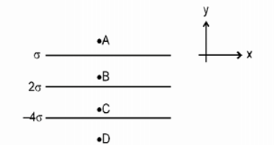 |  |  |  |  |  |  | 5
33. | - State the Lorenz’s force and express it in vector form. Which pair of vectors are always perpendicular to each other? Derive the expression for the force acting on a current carrying conductor of length l in a uniform magnetic field ‘B’.  - A rectangular loop of wire of size 2.5 cm × 4 cm carries a steady current of 1 A. A straight wire Carrying 2 A current is kept near the loop as shown. If the loop and the wire are coplanar, evaluate the magnitude and direction of the force on the loop due to the current carrying wire.  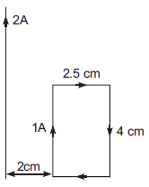  OR  - State the principle of a moving coil galvanometer. Draw labelled diagram of moving coil galvanometer and hence prove that the current flowing through the coil of a moving coil galvanometer is directly proportional to its deflection.  - How can a moving coil galvanometer by converted into an ammeter? To increase the current sensitivity of a moving coil galvanometer by 50%, its resistance becomes twice its initial resistance. By what factor does its voltage sensitivity change? |  |  |  |  |  |  | 5
 | SECTION E
34. | CASE STUDY 1  The emf of a cell is the maximum potential difference between two electrodes of the cell when no current is drawn from the cell. Internal resistance is the resistance offered by the electrolyte of a cell when the electric current flows through it.  For a freshly prepared cell, the value of internal resistance is generally low and goes on increasing as the cell is put to more and more use. The potential difference between the two electrodes of a cell in a closed circuit is called terminal potential difference and its value is always less than the emf of the cell in a closed circuit
- 1 | - Plot terminal potential difference versus external resistance graph |  |  |  |  |  |  | 1
 | - Three cells of emfs E₁, E₂ and E₃ and internal resistances r₁, r₂ and r₃ are connected in parallel. Find the ratio of net emf and net internal resistance of the given circuit. |  |  |  |  |  |  | 1
 | - The following graph shows the variation of terminal potential difference V, across a combination of three identical cells in series to a resistor, versus the current,  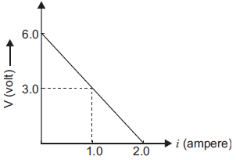  Evaluate the internal resistance of each cell  OR |  |  |  |  |  |  | 2
Two batteries A and B whose emf is 2V are connected in series with external resistance R = 1 Ω. Internal resistance of battery A is 1.9 Ω and that of B is 0.9 Ω. Evaluate potential differences across battery A .
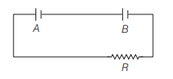
- 35  35. | CASE STUDY 2- Biot-Savart’s Law In Physics,  Biot-Savart law illustrates the generation of magnetic field by a stable electric current. This law is very basic to magnetostatics and plays a key role with Coulomb’s law in electrostatics. It can be used for calculating magnetic reactions at the atomic or molecular level. It is also used in explaining the theoretical concepts of aerodynamics for the calculation of velocity. According to Biot-Savart’s law, the magnitude of magnetic field produced at a point is directly proportional to current, length of the element and inversely proportional to the square of the distance between element and the point.  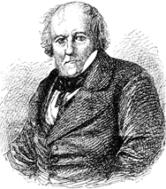
 | - Write the vector expression for Biot Savart’s law |  |  |  |  |  |  | 1
 | - Write any one dissimilarity between Biot Savart’s law and coulomb’s law |  |  |  |  |  |  | 1
 | - The magnetic field at the center of a tightly wound coil with 150 turns is 15.7 x 10⁻⁴ T. If the radius of coil is 12 cm, then evaluate the value of current flowing through it.  OR |  |  |  |  |  |  | 2
 | c)Two very small identical circular loops, (1) and (2), carrying equal currents I are placed vertically (with respect to the plane of the paper) with their geometrical axes perpendicular to each other as shown in the figure. Find the magnitude and direction of the net magnetic field produced at the point O. |  |  |  |  |  | 



